AMIT
: amitj0215@gmail.com, : +91-7982383573, 8010294241
: SEC 103, NEAR RADHA KRISHANA MANDIR V.P.O. DAULTABAD, GURUGRAM (HR) ,122006
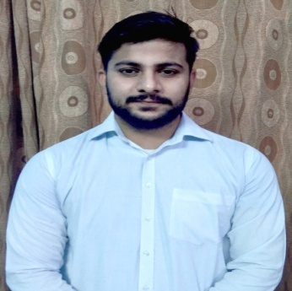
Mechanical Engineer
2 Year Experience In Quality As QC in SUPRAJIT ENGINEERING LIMITED, BHIWADI, RAJASTHAN.
6 MONTHS Project Training HONDA MOTORCYCLE AND SCOOTER INDIA PVT. LTD. MANESAR GURUGRAM.
4 Week summer Training in QH TALBROS ,UDHYOG VIHAR, GURUGRAM.
Increment in salary by 20% - 25% this year.

PROFILE SNAPSHOT
- Demonstrating how a product meets a client’s needs.
- Understating the Strategic Planning & Total Scope of the project to achieve the project specific goals.
- Maintaining coordination with all key members of the project team.
- Initiating and planning timely project that fulfil the requirement of customers.
- Preparing the reports (daily, weekly and monthly) to update the status of project to top management.
- Supervising and inspection of assembly work.
- Coordinating & participating in project review meetings and follow-ups with client, consultants.
- Monitoring and assuring all project related compliance.
- Maintain relationships with our customer, ensuring no problems at customer end by telephonic meeting on daily basis.
- Collecting new ideas from seniors, juniors and college .
- Closing of the project in system technically and commercially completely.
- Updating knowledge on the technical and taxation front.
- Calibrating all in process and final inspection gauge as per given plan and time
- Layout cables at final inspection as per given plan and time.
- Preparing pre dispatch inspection reports before dispatch.
- Sample inspection and preparing report of new models.
- Through knowledge of quality 5s, Kaizen, Poke-Yoke, Work instruction, cost saving suggestion, waste elimination through Kaizen.
- Basic working knowledge of Profile Projector.
- Basic knowledge of PPAP Documentation.
- Preparation for customer audits.

WORK EXPERIENCE
- Undergo 4 week training in QH TALBROS, Udhyog Vihar,Gurugram
- Undergo 6 months internship in HONDA MOTORCYCLE AND SCOOTER INDIA PVT. LTD. MANESAR GURUGRAM
- 2 years working experience SUPRAJIT ENGINEERING LTD., BHIWADI, RAJASTHAN.
( MARCH 2017 TO 30 Non. 2018)
Currently working in Sk springs co. Behrampur Road Gurugram.
( 1 feb, 2019 to till Date)

ACADEMIC & PROFESSIONAL CREDENTIALS
Course | School/Collage | Year Of Passing | Percentage
B.Tech. in Mechanical | Gurgaon Institute Of Tech. & Management | 2015 | 65.45%
12th | Jiwan Jyoti Sr. Sec. High School (HBSE BOARD) | 2011 | 75%
10th | Rikha Ram High School (HBSE BOARD) | 2009 | 86%

EXTRA CURRICULAR ACTIVITIES
- Certification in AUTOCAD 2D+3D.
- Basic computer knowledge.

Industrial Training
- In my academic year I got the opportunity to undergo my Industrial Training for 4 weeks at QH TALBROS ,UDHYOG VIHAR GURUGRAM.
- In my academic year I got the opportunity to undergo my Internship for 6 month at HONDA MOTOR SCOOTER INDIA PVT. LTD. ,MANESAR GURUGRAM.

PERSONAL DETAIL
Name : Amit
Father’s Name : Shri Krishan
Date of Birth : 26 July, 1992
Sex : Male
Nationality : Indian
Languages : English & Hindi
Marital Status : Married
Current Address : Sector 103, Gurugram Permanent Address : Near Radha Krishan mandir, V.P.O. Daultabad, Gurugram (HR), 122006
Email Address : amitj0215@gmail.com
Contact Number : 7982383573
Alternate Contact : 8010294241

I hereby declare that the above-mentioned information is correct up to my knowledge.

DATE :- ….......... Submitte
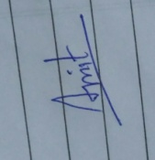
PLACE :- ………………….. AMIT

