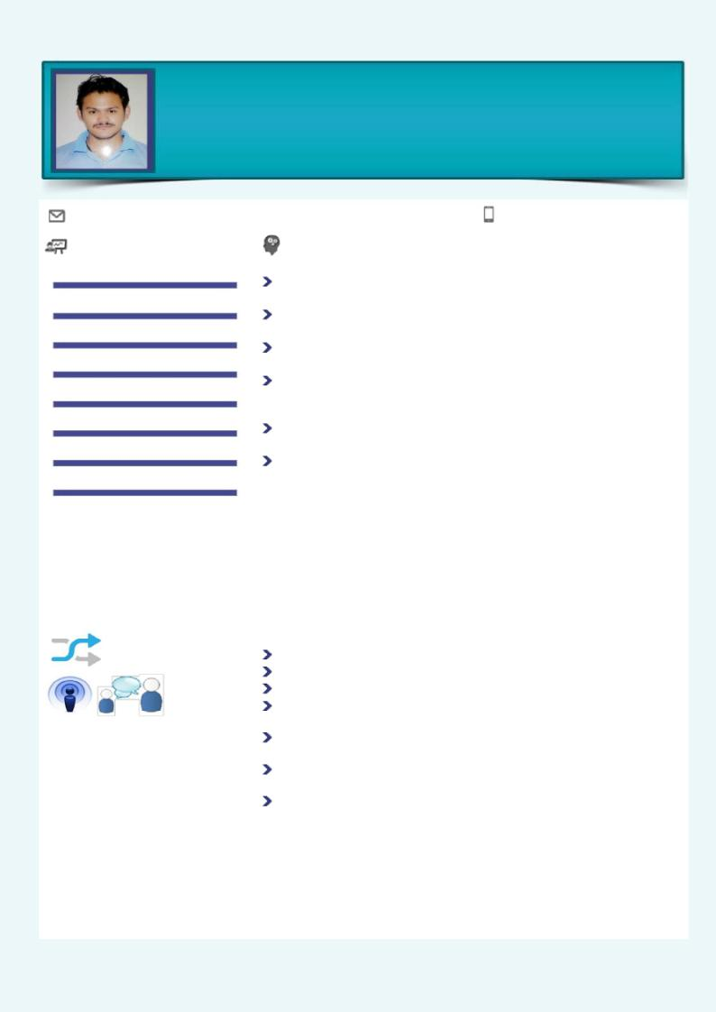
Pankaj Singh Bora

SR. Engineer – Engineering Services

12 years of rich experience in Engineering fields to support the quality production through reducing uneven unplanned machine breakdowns, cost saving through energy conservation plans and Open Access plateform,

pankajbora@outlook.com | + 91 – 9410717017

 | Areas of Expertise |  |  |  | Profile Summary
 | Energy Management
 |  |  |  |  | Presently associated with Galwalia Ispat Udyog Pvt. Ltd . as Sr. Engineer; leading
 |  |  |  |  | Engineering services, improvement, optimal capacity utilization.
 | Open Access – Power Purchase at IEX
 |  |  |  |  | Expertise in managing Preventive maintenance & predictive maintenance to run
 | Electrical & Instrumentation |  |  |  | production without hamper.
 | Utility |  |  |  | Expert in power purchase from Open access at IEX plateform, cost reduction in
 |  |  |  |  | power cost
 | Plant Maintenance |  |  |  | Excels in leading all aspects of Plant Operations from streamlining systems,
 |  |  |  |  | logistics, machinery maintenance, inventory control, vendor management to new
 | Material Management |  |  |  | technology implementation in adherence to regulatory compliances
 |  |  |  |  | Exhibited strong leadership skills inmanaging manpower organising trainings for
 | MIS Reports |  |  |  | staff/ new employees to improve their productivity & skills
 |  |  |  |  | Effective Leader with proven talent in maintaining a positive work environment
 | Trainings |  |  |  | for accomplishment of organizational goals; recognized for excellent problem-
 |  |  |  |  | solving, decision-making & analytical skills

Soft Skills Key Achievements

 |  |  |  |  | .
 |  | Communicator |  |  | Certified by the company (SRF Level) in Energy Conservation program
 |  |  |  |  | Handle the IMS audits
 |  |  |  |  | Successfully erection & commissioning of 8.7 BOPET Line.
 |  | Collaborator |  |  | Successfully erection and commissioning of Husk Heater & Pet Coke Thermid fluid
 | Innovative |  |  |  | heater to reduce the fuel cost.
 |  |  |  |  | Successfully upgradation of Air handling system from old technology to new
 |  |  |  |  | technology
 |  |  |  |  | Played a key role in conducting Monthly Reviews of achieved targets, performing
 |  |  |  |  | RCA of failures and taking corrective actions (CAPA)
 |  |  |  |  | Promoted to senior positions on account of excellent performance and won
 |  |  |  |  | awards & appreciations.

2017– Till Date

Galwalia Ispat Udyog Pvt Ltd.

Senior Engineer

2010– 2017

SRF Limited

Engineer – Engineering services

2009-2010

Polyplex Corporation Ltd. Junior Manager

2007 – 2009

Pasupati Acrylon Ltd. Assistant Engineer

2005-2007

Surya Roshni Ltd. Junior Engineer

2003

Diploma in Electronics & Telecommunication

Career Timeline

Organizational Experience
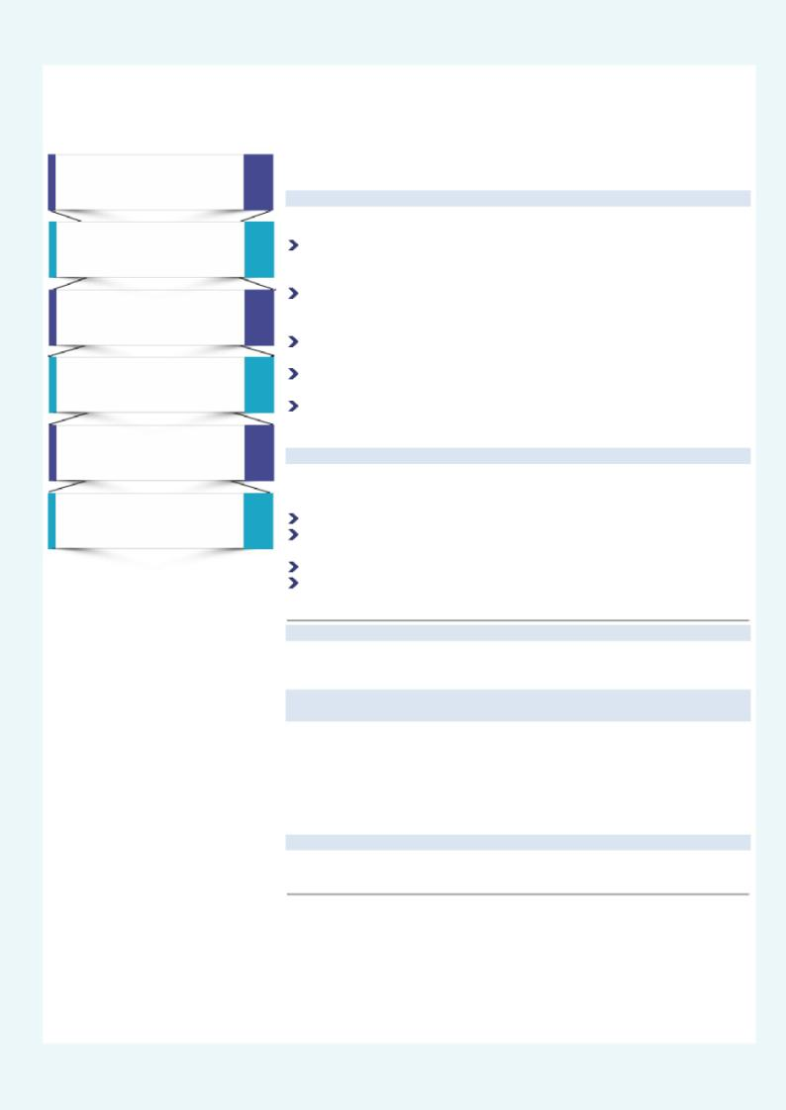
Since July’17 Galwalia Ispat Udyog Pvt. Ltd., as Senior Engineer – Engineering Services

Key Result:

Planning day-to-day job schedules and allocating work for achieving targets; interacting with Management to enhance plant capability and capacity through technology transfer

Ascertaining material requirements for department, interfacing with vendors for cost effectiveness & timely sourcing of quality material; establishing quantity limits for effective inventory control & reducing wastages

Effecting preventive maintenance schedules to increase machine uptime & reliability; managing plant start–up, shutdown and emergency conditions

Taking stringent quality measures including preparation of necessary documents /

MIS Reports to ensure compliance with specified standards

Leading & monitoring the performance of team members to ensure efficiency in operations; organising training for workforce to increase their productivity

Jan’05 – Jul’17: SRF Ltd., last designated as Engineer – Engineering Services

Growth Path: Joined as a Trainee & rose to the position of Sr. Engineer throughpromotions

Key Result Areas:

Energy Management & Conservation

Planned machinery maintenance schedules for streamlined operations without

any failure; monitored raw materials usage & controlled inventory movement Projects regarding Energy

Organized training & development of employee

Aug’2010 – Jul’17: SRF Limited, Kashipur as Engineer Engineering Department

Done various project i.e. New BOPET Line & Energy related with handing the plant maintenance .

Previous Experience

Mar’09–Aug’10: Polyplex Corporation Limited, as Junior Manager- Electrical &

Instrumentation
Erection & Commissioning of BOPET Line & PET Chips Plant

 | Day to day maintenance, Preventive |  |  | Aug’07–Mar’09: Pasupati Acrylon Limited, as an Assistant Engineer –
 | maintenance, Predictive maintenance |  |  | Instrumentation
 | breakdown maintenance, inventory |  |  | Erection & Commissioning of Distillation plant (Recovery section and Section Incharge
 | control, IMS |  |  | of Poly Plant
Jan’05– Aug’07: Surya Roshni Ltd, as an Junior Engineer – Instrumentation

Shift Incharge

Education

Trainings / Project

Diploma in Electronic & Telecommunication from Government Polytechnic,
Kashipur in 2003

Perusing in B-Tech (6th Semester)

Siemens PLC – 300 Basic by Siemens SITRAIN Industrial Health Safety & Environment and First Aid Problem Solving Project – ( Energy Conservation) Erection & commissioning of 150MTD PET Chips plant Erection & Commissioning of 8.7 Mtr Width BOPET Line

Erection & Commissioning of Green Fuel Fire Thermid Fluid Heater Erection & commissioning of Sold Fuel fire Thermid Fluid Heater Erection & Commissioning of Distillation Plant DMF Recovery Small Energy Conservation projects

IT Skills

Personal Details

MS Office (Word & Excel, PowerPoint presentation), Data Processing, ERP Oracle, Internet

Date of Birth: 28th May, 1983
Languages Known: English, Hindi & Punjabi

Address: Devi Kripya Sadan , Guru Gobind Singh Colony, Jaspur Khurd, Kashipur - 244713, U.S.Nagar, Uttarakhand Location Preference: Uttarakhand , Himachal, NCR, Oveerseas

Industry Preference: Manufacturing, Chemical, Rubber, Pharma / Open Current CTC : 9.0Lacs per annum

