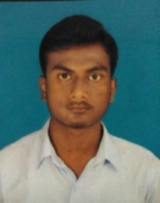
CURRICULUM VITAE
ANUWAR HOSSEN SEKH
DATE OF BIRTH:-22/08/1997

ADDRESS (P):- Vill : - Highland
P.O.:- Nainan
P.S.:- Ramnagar
Dist.:- 24-Parganas(S)
PIN:- 743504
West Bengal

C0NTACT No: - +917797173343
EMAIL ID: - ahsekh3@gmail.com

OBJECTIVE:-To grow as a successful Electrical Engineer in field and serve the organization concerned loyally thus contributing something positive to the society.

EDUCATIONAL BACKGROUND:-
QUALIFICATION | SCHOOL/INSTITUTE | BOARD/COUNCIL | YEAR OF PASSING | PERCENTAGE
10thStandard  (X) | Khandalia High School | WEST BENGAL BOARD OF SECONDARY EDUCATION | 2013 | 61.57%
TECHNICAL BACKROUND:-
QUALIFICATION | SCHOOL/INSTITUTE | BOARD/COUNCIL | YEAR OF PASSING | PERCENTAGE
12thStandard  (XII) | Khandalia High School | WEST BENGAL STATE COUNCIL VOCATIONAL EDUCATION &TRAINING | 2015 | 69.50%
DIPLOMA | Sree Ramkrishna Institute Of Science & Technology | WEST BENGAL STATE COUNCIL TECHNICAL EDUCATION | 2017 | 3rd sem | 67.60%
 |  |  |  | 4th sem | 68.30%
 |  |  |  | 5th sem | 66.20%
 |  |  |  | 6th sem | 68.00%

I have completed my DIPLOMA in ELECTRICAL ENGINEERING from SHREE RAMKRISHNAINSTITUTE OF SCIENCE & TECHNOLOGY, Sonarpur (under West Bengal State Council of Technical Education).

SUBJECTS OF INTEREST : - Electrical Machine,
Switch Gear & Protection.
TRAINING ATTENDED : - WBSEDCL Substation.
LANGUAGE PROFICIENCY : - English, Hindi & Bengali.
EXTRA CURRICULUR ACTIVITY : - Computer basics.
HOBBIES : - Travelling,
Internet Surfing,
Playing Cricket.

I HERE BY DECLARE THAT ALL THE ABOVE INFORMATION IS CORRECT.
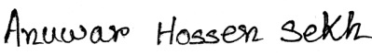
Date-26/09/2017
Place-Kolkata (Signature)

