CURRICULUM -VITAE
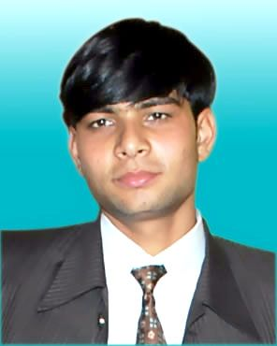

NITIN SHARMA
Permanent Address- H.N. 660, Near Janta Kanya Inter College
Shivpuri Khatauli Muzaffarnagar (U.P)
Contact No. +91-9927830081, 7983952064
E-mail- nitinkumar_8300@yahoo.com

Career Objective:-

Intend to build a career with leading corporate of hi-tech environment with committed & dedicated people, which will help me to explore myself fully and realize my potential. Willing to work as a key player in challenging & creative environment.

Experience:-

I worked 3 year in Pritul Machines Industrial Area Begrajpur,Muzaffarnagar (U.P) (makes bakery machines) as Milling Machine Programmer (Solid Cam) & Junior Design Engineer (Auto Cad & Solid Work).

I worked 1 year as Junior Design Engineer at Solid Works (also sheet metal fabrication) & Auto Cad in Hardayal Engineering Works (p) Ltd Ghaziabad (Makes Paper & Pulp Machine).

I am working as Junior Design Engineer, Wire Cut programmer & Operator (Solid Works & Auto Cad) in Tool Room in A.S. Industries, Rai Industrial Area , Sonepat (Haryana) last 1 year.

Educational Qualification:-

3 year diploma with Mechanical Engineering passed from JanardanRai Nagar RajasthanVidyapeeth University (Udaipur) With65% in 2011.

10+2 passed from U.P. Board with 58% in 2011.
- 10th passed from U.P. Board with58.83% in 2005.

Computer Skills

Basic Knowledge of Computer Application. (MS- Office)

Auto Cad,Pro/Engineer,SolidWorks,Catia

Internet

Professional Qualification:-

Four month Diploma in Auto Cad & Pro/Engineer from Cadd centre Training Services , Meerut.

One month Diploma in Catia from Cadd centre TrainingServices , Meerut.

Summer Training:-

One month industrial training in Triveni Engineering & Industries Ltd (Sugar UnitKhatauli, Muzaffarnagar (U.P) from 4.2.2010 to 3.3.2010.

Hobbies:-
- Reading books, Play cricket

Languages Known:-

Read | Write
Hindi √ | √
English √ | √

Personal Details:-

Father’s Name : Shri. Dinesh Kumar Sharma

Date of Birth : 27thjuly 1989

Marital Status : Single

Nationality : Indian

Date:-

Place:-Khatauli (NITIN SHARMA)

