RESUME
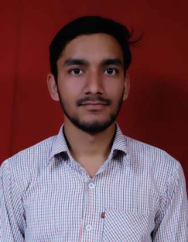
HARSHIT KUMAR
Current Address:
HSIIDC SIDCO ARAVALI
SECTOR-1 IMT MANESAR, GURGAON
E-mail:agarwalharshit147@gmail.com
Cellular: +91-9760830664, 7409072502
Date of Birth: July 30th 1995
Gender : Male
Career Objective:
To work in an environment, which can provide me an opportunity to learn and grow in manner through which I can experience my contribution to work the success of the organization and at the same time the job could provide me satisfaction and stability.
Academic Qualifications:
Qualification Year Institute Perc.(%)
B.Tech 2012- 2016 Uttarakhand Technical University 71.9
(Mechanical Engg.)
Intermediate 2012 U.K. Board 70.8
High School 2010 U.K. Board 80.4
KEY SKILLS AND COMPETENCIES:
- Hard working
- Confident
- Ability to grasp things easily
- Always a Positive thinker
Achievement:-

GATE qualified in 2017.

Marks obtained :- 36.34/100

Summer Internship:
0rganisation – Bharat Heavy Electricals Limited June 2015- July 2015
Place - Ranipur Haridwar
Project Title – “Knowledge of various tools used in machining of either turbine or generator parts”
PROJECT UNDERTAKEN:

Project Title: Automatic Canal Cleaning System
Objective : To clean the canal and rivers with the help of automatic machine
Description: In this hopper and conveyor belt assembly is used. In this sensor is also used for automation.
CERTIFICATIONS:
- Completed 6 week designing course CATIA from CETPA Roorkee
- Completed analysis course ANSYS from CETPA Roorkee

Extra Curricular Activities:
- Cleared Virtual round of National Kart Racing Championship
- Participated in Junkyard Competition
- Participated in Mind Game
- Participated in CAD-MAD event
- Participated in Man Machine competition

Minor Projects:

- Radial Engine Assembly in CATIA
- Wheel support Assembly in CATIA
- Piston analysis in ANSYS

Area of Interest:
- Production
- Research and development
- Quality control

Personal Details:
Marital Status : Single
Languages Known : English, Hindi
Hobbies : Playing Cricket, Chess
Nationality : Indian

Declaration:

I hereby declare that all the information mentioned above is true to the best of my knowledge.

Date:

Place: (HARSHIT KUMAR)

