Curriculum Vitae

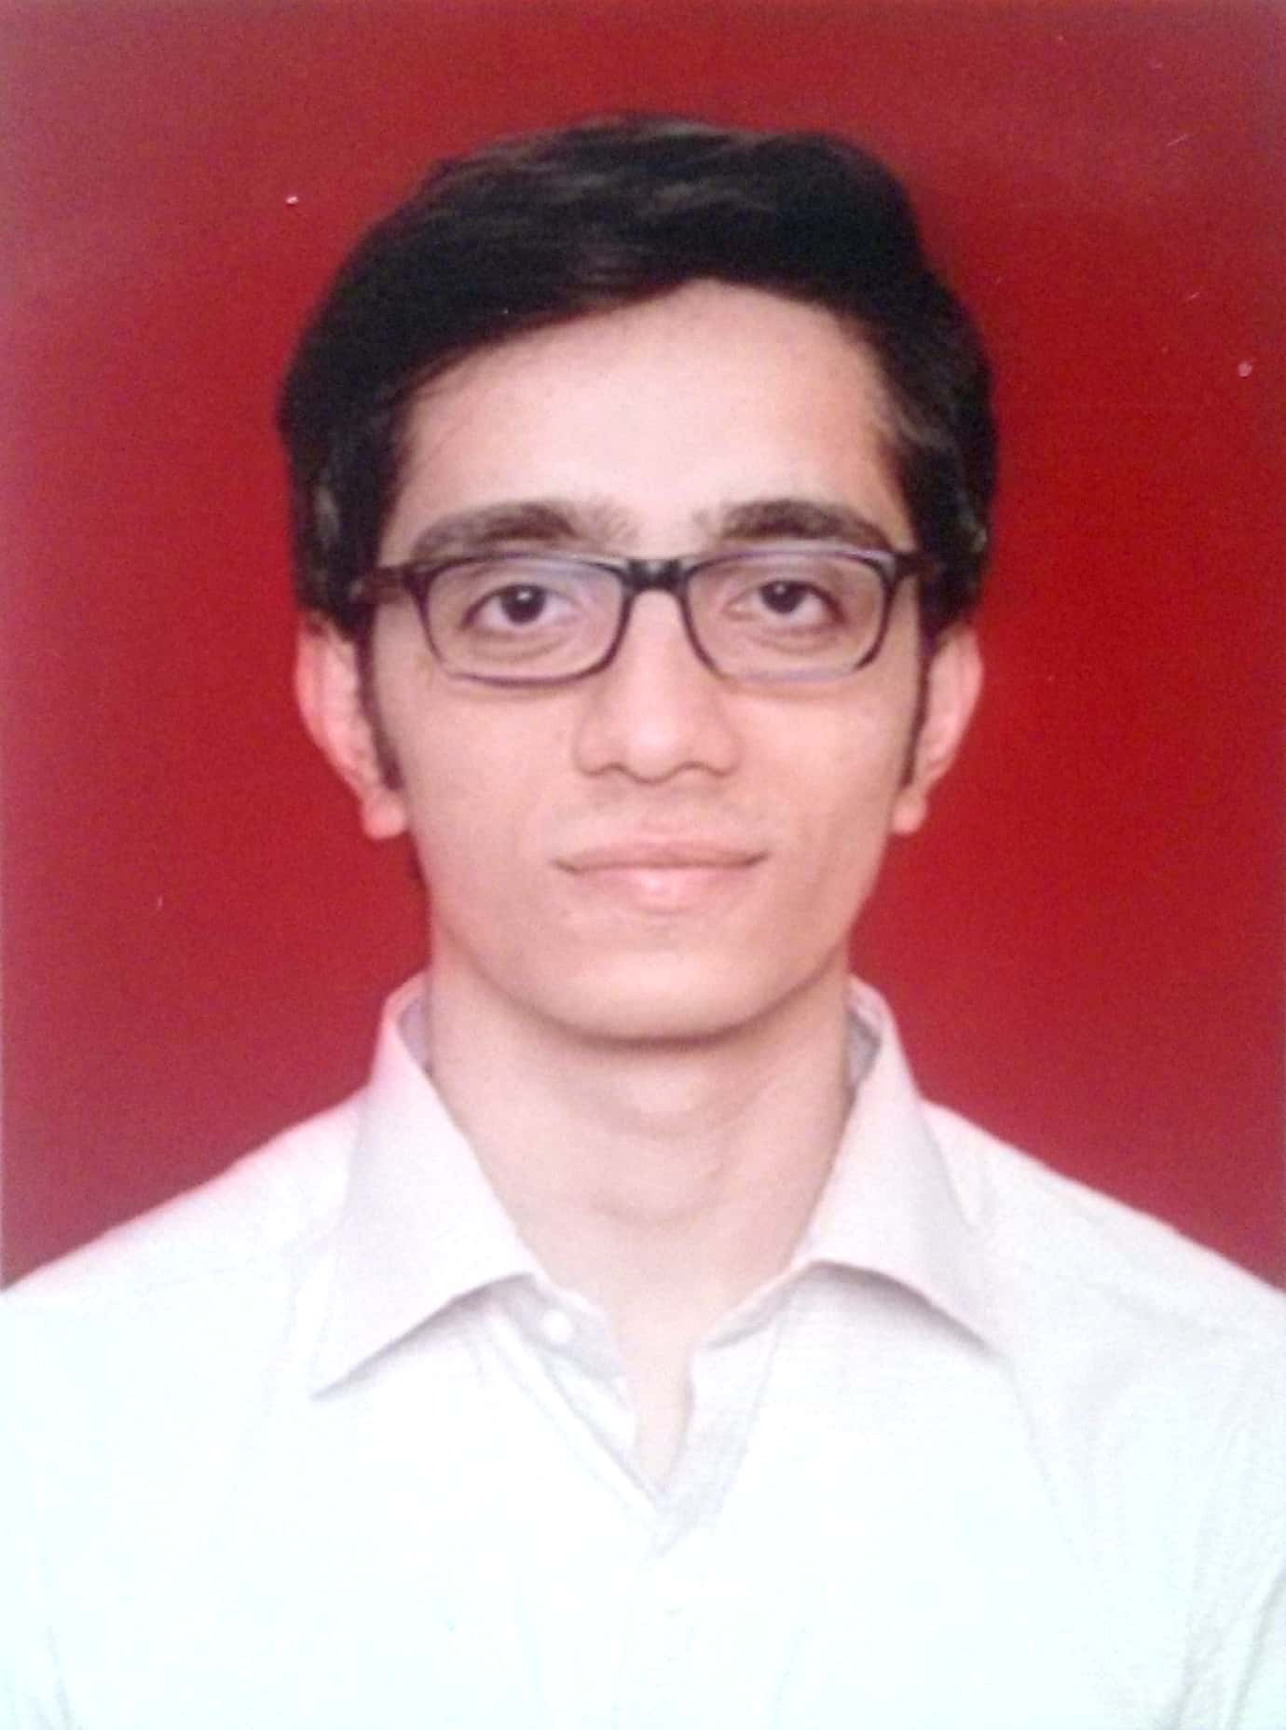
Name: Umesh R. Satashia
Gender: Male
Address: 202/Shree Vaishali C.H.S., W.S. Road, Opp.
Janseva Bank, Dahisar-(E), Mumbai - 400 068.
Contact No.: 0091-9870646477
Email ID: umeshrssatashia2010@gmail.com

Career Objective:

To search for a position in Mechanical/Automobile Engineering (Designing, Manufacturing, Service) that will allow me to improve my knowledge and technical skills also seek the opportunity to learn new skills for future use.

Education:
Exam Passed | Institute | Board/University | Year | Percentage
B.E. in  Automobile | M.H. Saboo Siddik College of  Engineering, Byculla | Mumbai University | 2016 | 6.42 (CGPI)
IELTS | IELTS British Council | British | 2017 | 6.5
GATE | GATE 2017 | IIT ROORKEE | 2017 | 33.25  (AIR 26373)
Secondary Education | T.P. Bhatia, College, Kandivali-(W) | Maharashtra Board | 2012 | 70.00%
Primary Education | S.V.P.V, Dahisar-(E) | Maharashtra Board | 2010 | 84.18%

- GATE – Graduate Aptitude Test in Engineering
- IELTS – International English Language Test System
- AIR – All India Rank

B.E Project: Motorcycle Dynamics & Engine Tuning.

Our project was totally based on pure Automobile Engineering i.e. to manufacture a 2- stroke Dirt Bike. Which was built according to our own design and material selection for the chassis. Our focus while manufacturing the bike was to keep the bike light weight, strong enough and as compact as possible to improve handling and to increase power to weight ratio.

Team was of 5 members. We divided ourselves according to our subject of interest though everyone was aware acknowledged about everything.

Work Experience:

I am currently employed at Prime Machine Tools, Mumbai – India, as a Sales & Service Engineer.
I am working with this company since February 2017 till now.

Technical Proficiency: Learned During Curriculum

CAD softwares: AutoCAD, Solidworks, ProE, Ansys.
SAE INDIA Member for 5 Years and organized events during College events.
IEEE Workshop Phase 1 - Certificate.
Good Command over operations like Lathe, Shaping, Drilling, Milling, Smithy.

Key Skills:
Patience. Creativity
Self-motivation. Leadership
Lifelong Learning. Analyzing & Investigating

Hobbies:
Movies. Exploring New Places
Football. Adventure
Reading.

Personal Detail:

Languages Known: Gujarati (Mother Tongue), English and Hindi (Learning German)
Date of Birth: 27th September 1994.

Declaration:
I hereby declare that the above given information is true to the best of my knowledge and belief.

Date:

Place: Mumbai Signature

