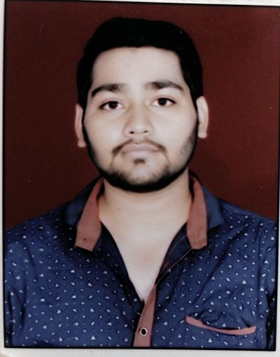
PRODUCTION PLANNING AND CONTROL
VIPIN SHARMA
Phone:+91.8882969073
Email:Vipin.kumar8982@gmail.com
LinkedIN:linkedin.com/in/vipin-sharma

PROFILE

Production Planning and Control Engineer
Production planning and control involves the coordinates and expedites the flow of work and materials within or between departments according to daily and weekly or monthly based production schedules. Duties include reviewing and distributing production, work, and shipment schedules; conferring with department supervisors to determine progress of work and completion dates; inventory levels, and solving production problems and troubleshooting with managers.
EDUCATION

Bachelor of Technology, MECHANICAL ENGINEER Graduated, July 2016
AKIDO COLLEGE OF ENGINEERING Marks 69.9%
MAHARSHI DAYANAND UNIVERSITY Division 1
Bahadurgarh, Haryana
10+2 Completed, May 2012
Sarvodaya Boys SSS K-Block Marks 59.6%
CBSE Board Division 1
New Delhi, Delhi
10 Completed, May 2010
Sarvodaya Co-Ed SSS C-Block Marks 72.44%
CBSE Board Division 1
New Delhi, Delhi

SKILLS

● Effective technical skills
● Ability to work under pressure
● Problem-solving skills
● Interpersonal skills
● Creativity
● Verbal and written communication skills
● Commercial awareness
● Work with Team skills or Individually
WORK EXPERIENCE
August 2016 – Current
Production Planning and Control
Happy Forgings Limited
Ludhiana, Punjab

Project
● Induction hardening
Period: December 2016 - March 2017
Developed ASHOK LEYLAND, EICHER VOLVO and SAME crankshaft by applying and change so many parameters like Power, Time, Quench delay time, Quench pressure, Transformer ratio and Polymer percentage.
Internships

● July 2014 - August 2014
Production Engineer
Hindustan national glass industries & ltd
Bahadurgarh, Haryana
● July 2015 - September 2015
Production Engineer
Bharat gears limited
Faridabad, Uttar Pradesh
● February 2016 - May 2015
PPC Engineer
Garg Inox limited
Bahadurgarh, Haryana
I completed my 6 weeks training
Certifications

● Embedded systems and Robotics, Akido College of Engineering, 2013
COMPUTER PROFICIENCY

● Word 2010
● Excel 2010
● Internet explorer and Basic Knowledge of Autocad

LANGUAGES

● Hindi
● English
INTERESTS

● Sports,Outdoors
● Listening music
● Social networking
Extra Curricular Activities

● Actively Participated in Intercollegiate cricket and Badminton competition
● Participated in Stage Drama Show at school held on Annual day in year 2011
PERSONAL DETAILS

Father’s Name: Mr. Ved Prakash Marital Status: Single
Birthday: JUNE 18, 1993 Nationality: Indian
Gender: Male
Declaration
I, Vipin Sharma, hereby declare that the information contained herein is true and correct to the best of my knowledge and belief.
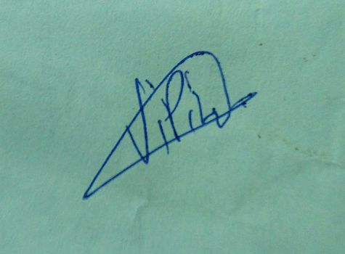
____________________________
Vipin Sharma New Delhi, Delhi
June, 2017

