MAHENDRA NATH TUDU 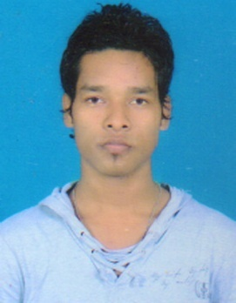
pzain110@yahoo.com
(Mobile)-8076916478 /9162224421

CAREER OBJECTIVE
- Accepting the challenge of the work where I can exhibit my skill and strength in order to achieve the mission and objectives of my organization.
EDUCATIONAL QUALIFICATION
- I have completed my DIPLOMA from SCTE &VT, ODISHA board in the year 2014 secure 64%.
- I have passed my 10th examination from JAC RANCHI board in the year 2008 secure 64%.

TRAINING & ACCOMPLISHMENTS

- I have completed CENTRAL TOOL ROOM & TRAINING CENTER, BHUBANESWAR as a trainee in Post Diploma In Tool Design And Manufacturing (PDTDM) course for one year of duration.
- I am pursuing in SONA BLW PRECISION FORGINGS LTD as a trainee from 10th SEP 2015.

SOFTWARE SKILLS
- AUTO CAD
- CREO PARAMETRIC 2.0
- UNI GHRAPHICS
- CATIA PART PROGRAM
- PART PROGRAM

PROJECTS UNDERTAKEN
- I have done a project on PRESS TOOL & HAND INJECTION MOLD in my institute.

STRENGTHS
- Hard working person.

HOBBIES
- Playing
- Drawing
INTERESTS
- To watch discovery channels & to play sports games.
PERSONAL DOSSIER

Date of Birth : 2nd FEB 1991
Father’s Name : LATE NABAGHAN TUDU
Address :At-HALUDBANI DUNGRI TOLA, Po-PARSUDIH, Ps-PARSUDIH, JAMSHEDPUR, Dist-EAST SINGHBHUM, Pin-831002, JHARKHAND
Nationality : Indian
Languages Known : Hindi, English

DECLARATION

I do hereby affirm thatthe above furnished information’s are true and correct to the best of my knowledge and belief and proof of which will be produced on demand.

Date: 1st DEC 2016 MAHENDRA NATH TUDU
Place: JAMSHEDPUR SIGNATURE

