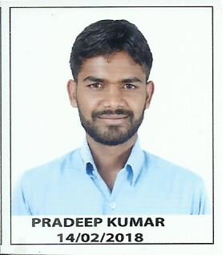
CURRICULUM VITAE

PRADEEP KUMAR
[E-mail] : pradeepmahto.mahto3@gmail.com
Mobile no. : +918310871899

Objective:
A progressive carrier with an organization where my technical knowledge and my creative thinking will contribute to the organization’s achievement and my growth be a part of successful team accomplishing the goal.

Educational Qualification:
Name of Exam | Name of University/Board | School/College | Year of passing | Result Agg.(%)
Diploma (Automobile) | Deemed University | B.I.T Mesra Ranchi | 2012 | 61.4%
Matriculation | JAC | S S High School Childag,Angara Ranchi | 2009 | 78.2%

Technical Qualification:
2 year technical certification course by NTTF Bangalore in “manufacturing technology” under “LEARN & EARN” program.
- I had been appointed as a trainee in IFB Automotive PVT LTD. Which is one of the leading manufacturing industry. Ihave learned about manufacturing process like welding, riveting, clinching, caulking, assembly of parts and have sufficient knowledge about setting tools of the same.
Following are roles as a trainee performed in two years certification program.
- First year – Worked as a operator from April 2016 to March 2017.
- Second year – Worked as Assistant supervisor from April 2017 to Now.

Experience:
- Six month training in premsons motors kanke road ranchi.
- One year training in tata motors budhia agencies booty more ranchi.

Academic Project:

Project Title: | Single wheel electric vehicle
Duration: | 1 Year

Strengths:
- Hard working.
- Honest,Self confidence.
- Positive attitude.
- Better performance in all situation.

Hobbies and Interests:
- Plantation.
- Watching tv.

Personal Details:
Father’s name: Mr. Balaram Mahto
Mother’s name: Mrs. Kajari Devi
Date of birth: 27-04-1994
Permanent address: Vill-Turup,P.O-Hesal,P.S-Angara,Dist-Ranchi,
State-Jharkhand,Pin-835103
Languages Known: English,Hindi and Regional(speaking & writing)
Sex: Male
Marital Status: Unmarried
Nationallity: Indian

Declration:
I hereby declare that all the imformation mentioned above are true and best of my knowledge.

Place: Ranchi
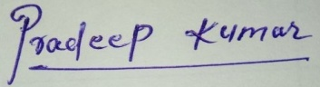
Date: __ / __ / ____

signature

