CURRICULUM VITAE
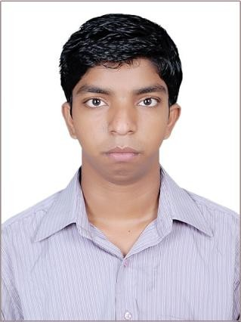
Name: Biswaranjan Ray

Present Address
At: Krushna Nagar, Po-Serpur
Dist: Jajpur, Odisha-755010
Mobile: 9583837156
Email: raybiswa61394@gmail.com

Career Objective:
To work in a healthy, innovative and challenging environment extracting the best out of me which is conducive to learn and grow at professional as well as personal level thereby directing my future endeavors as an asset to the organization.
Academic Qualification:
Academic Qualification | Institute/ University | Year of Passing | Percentage
B.Tech. | Govt. College Of Engineering Kalahandi, Odisha | 2015 | 69.69
HSC | Kendrapada Autonomous College ,Odisha | 2011 | 70.00
SSC | Chandra Sekhar High School ,Odisha | 2009 | 73.33

Achievements:

- Scholarship holder for 4 years during engineering provided by the college trust / Govt.

Summer Internship courses:
- One month Industrial Automation programming (PLC programming) at Central Tool Room & Training Centre, Bhubaneshwar (CTTC) from 15th-June-2013 to 13th-July-2013.

Courses-1. Electrical Actuator Application
2. Programmable logic controller hardware details
3. Programming PLC by Sematic Manager Software.
4. Application of OB.

- One month Practical Training on Transmission and Distribution at Odisha Power Transmission Corporation Limited from 14th-May-2014 to 12th-June-2014.

Courses- 1.Overview of Transmission and distribution system.
2. Types of Transmission and distribution system (Like underground and overhead)
3. Instruments in switch ward like transformer (220kv / 132kv, 132kv / 33kv, 33kv/11kv, 11kv/400v), Insulators, Conductors, CT, PT and etc.
4. Testing of Transformer, Transformer oil, CT, PT, Insulators.
5. Controlling system like relay system, Battery (300AH, 220v).
6. Connection of Instruments.

Seminar:
- Instrument transformer (Achieved Grade-o) and the Seminar Topic was below:-
1. Types of instrument transformer like, current transformer (CT), Potential Transformer (PT)
2. Construction of instrument transformer
3. Application of CT and PT
4. Modern or combined CT and PT
5. Testing and connection of these

Academic Projects Undertaken:
1. Automatic irrigation system powered by solar energy (Major project).
Project Summary-
1. Develop a project using non convectional energy
2. Electronic devices used for low power consumed and high power output.
3. It is a microcontroller based project
4. Not only automatic irrigation but also automatic led lighting and solar. 5. Overall it is called a “Smart Farming”.
2. Three phase fault analysis with auto reset on temporary fault and permanent fault (Minor project).
Project Summary-
1. Definition and types of Electric Fault
2. Types of Electric fault and effects
3. Fault clearance by using low power consuming electronic devices like timer, Relay.

IT Skills:
- Well versed with MS Office Suite (Word, Excel & PowerPoint), Oracle, C, and C++, Networking & Internet Applications.

Interpersonal Skills:
- Quick Learner
- Positive Attitude, Good communication and interpersonal skills,
- Sincere, Responsible & hardworking

Personal Information:
D.O.B : 13/06/1994
Gender : Male
Hobbies : Playing cricket, Reading books
Languages Known : English, Hindi and Odiya.
Permanent Address : At-Krushnanagar, Po-Sherpur, Dist-Jajpur, Pin-755010
Father’s Name : Niranjan Ray
Contact No : 9583837156
Email ID : raybiswa61394@gmail.com

I hereby declared that above mention all information is correct to the best of my knowledge and belief.

Date:
Place: (Biswaranjan Ray)

