**Resume Navdeep rohilla**

**Tool room Information’s**

**House no. : 41/15.**

**Gandhi nagar, Khubru road,**

**Teh. - Ganaur, Dist. Sonipat.**

**131101 (Haryana).**

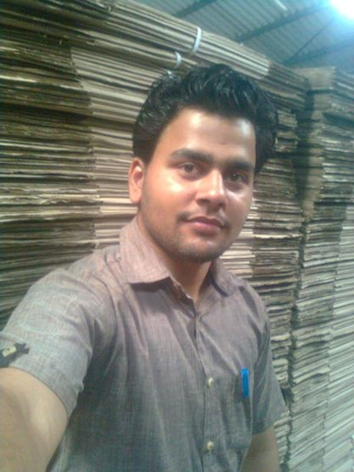**Mobile: 07357680143**

**08447227193.**

Email Address:

[mr.navdeeprohilla@gmail.com](mailto:mr.navdeeprohilla@gmail.com)

Linked connection:

[www.linkedin.com/pub/navdeep-rohilla/6a/9a3/483](http://www.linkedin.com/pub/navdeep-rohilla/6a/9a3/483)

**CARREER OBJECTIVES**

* Seeking a challenging and growth oriented career with knowledge and to become an asset of organization by giving my best complete up all the jobs successfully, given to me.

**EDUCATION**

* **10th from H.B.S.E**. Board in **2007** with 75%.
* Central Institute of Plastics Engineering & Technology (**CIPET**) Diploma passed the examination in the **First class** in the year **2012**.
* Certificate in AutoCAD, Pro-e, CATIA.
* Post Diploma from CIPET in the year **2013**.
* Now I am Study in **AMIE** Open Education.

**EXPERIENCE**

* **Pearl Polymers ltd, Bangalore.**

From 1 April 2013 to 30 Jul. 2013.

* **Pearl Polymers ltd, Bangalore.**

From 1 August 2013 to 7 Oct. 2014.

* **Gmax Auto ltd, Bawal, Rewari.**

From 10 October 2014 to 06 July 2015.

* **Motherson Sumi System limted,** **IMT Manasar.**

From 13 July 2015 to Till date.

**COMPUTER SKILLS**

* **Auto CAD** 14, 2006, 2007, 2010.
* **Pro-E**, **CATIA**, **UG ( Nx6 );** Collage knowledge.
* Certificate in basic knowledge of Computer & Internet.
* **Microsoft office** 2003 & 2007.

**WEAKNESS**

* Sensitivity.
* Trust peoples easily.

**HOBBIES**

* Reading books; Workshop, Pro-e, AutoCAD and other design related bookes.
* Listening music; Punjabi, Hindi and Soft music.

**PERSONAL PROFILE**

* Father’s Name Sh. Rajbir rohilla
* Mother’s Name Sh. Sheela rohilla
* Date of Birth 20.04.1993
* Gender Male
* Nationality Indian
* Marital Status Unmarried
* Language Known Hindi, Punjabi & English.

**STRENGTHS**

* Hardworking.
* Believing myself, Honesty.
* Easily to adopt the changing environment.
* Positive Attitude.
* Quick leaner.
* Confident.

**MACHINE KNOWLEDGE**

* **Tool Room machines**:

Grinder, Drilling, Milling, Power hacksaw, Lathe, Pantograph, Shaper.

* **CNC Machine**: Milling, Lath, Wire cut EDM.
* **ASB Machines** (Blow moulding machines).

**ISBM** (Injection stretch blow moulding)

**EBM Machine** (Extrusion blow mouding)

* **WETORI Diesporting machines**, Some other instruments.

**DECLARATION**

* I hereby declare that all the statements given

above are correct and true on behalf of my

knowledge. If a chance is given to me, I am sure that I will do best towards my work and conduct.