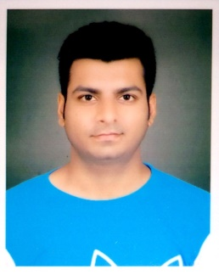

SHIVAM SRIVASTAVA
E-mail : mastershivam@live.com
Address: D-64/110 A Madhopur, Sigra,
Varanasi, Uttar Pradesh 221010.
Contact: 9140712289,8239773374

CAREER OBjective

To be a part of an organization where I can fully utilize my skills and make a significant contribution to the success of the employer and at the same time my individual growth.

EDUCATION QUALIFICATION

PRATAP UNIVERSITY, JAIPUR (2013-2017)
Completed BACHELOR IN TECHNOLOGY (MECHANICAL) and has successfully passed final year with 7.0 CGPA.
NATIONAL INSTITUTE OF OPEN SCHOOLING (2011-2012)
Passed HSC with 73% with PCM.
RAJ ENGLISH SCHOOL, VARANASI, CBSE (2009-2010)
Passed SSC with 5.4 CGPA

personal qualities

- Adaptability to change in environment.
- Highly motivated and eager to learn new things.
- Analyzing every angle of a project before working on it.
- Ambition and dedication to work.

SKILLS

AUTOCAD 2D & 3D, MS OFFICE, PHOTOSHOP

POsition of responsibility
- Coordinator of Sifalari-2K14 And 2K15(Pratap University Annual Cultural Fest)
- LAN-GAMING Coordinator of Pratap University Sports League(2016)
- Member of designing team in university.

OTHER ACTIVITIES
- Types of Automobile (Seminar Attended)
- Basic Concept of Vehicle Dynamics (Seminar Attended)
- Participated in cultural fest and sports at school and college level.
- Also participated in PPT’s and GD.

training

Industrial training at DURGAPUR STEEL THERMAL POWER STATION, DURGAPUR, WEST BENGAL.
Worked as trainee engineer at KAKRAPAR ATOMIC POWER PROJECT UNIT 3&4, GUJRAT, (NPCIL) NUCLEAR POWER CO. INDIA LIMITED for Ganpati Construction under project by Punj Lloyd.

PROJECTS

MINOR - POWER GENERATION BY SPEED BREAKER.
MAJOR - WIRELESS STEERING AND INTELIGENT VEHICLE.

Personal Details

Date of birth: 19th August 1995
Language Known: Hindi and English
Hobbies: Swimming, Photography, Gaming

Declaration

I hereby declare that the above information is true to the best of my knowledge and belief.

SHIVAM SRIVASTAVA

