Curriculum Vitae
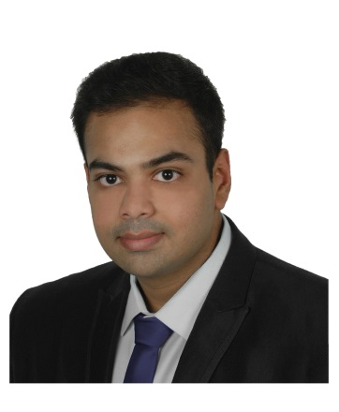

First Name Ayyappa Sainath Prabhu
Last Name Tirumalasetty
Address 3-6-440, 404, Himayatnagar, Hyderabad,
Telangana (India)
Contact Phone +919502319039 (mobile)
Contact email tirumalasetty.ayyappa@gmail.com
Date of Birth 24 August 1988
Marital Status Single
Nationality Indian

Work experience
July 14 – Sept 14
Nov 13 – Apr 14
Internship - Analysis and load simulation of solar Inverter
Tool: MATLAB, MATLAB Guide
Bosch Power Tec (BOSCH), Böblingen, Germany
- Created a Graphical User Interface(GUI) to evaluate reliability and life-time duration of photovoltaic inverter components.
Major Tasks
- Performed hardware testing, assembly and software programming of photovoltaic inverters.
Apr 10 – Oct 11
Employee - Quality Assurance Tester (QA Tester)
Electronic Arts (EA), Hyderabad, India
Major Tasks
- Assured product quality by manual testing.
- Prepared test reports, verified and reported issues.

Education

Master thesis - Optimal utilization of energy storage in combination with
Jan 15 – Aug 15
renewable energy sources for households (Grade - 1.7)
Technische Universität Darmstadt, Darmstadt, Germany
- Generated load profiles for German households.
- Applied Demand Side Management strategies - load shifting and peak shaving to reduce Peak to Average Ratio and to save energy costs.
- Evaluated state-of-art energy storage technologies such as Tesla Powerwall.
- Created a Graphical User Interface (GUI) using MATLAB Guide.
Tool: MATLAB
Oct 11 – Aug 15
Master of Science (M.S) in Electrical Power Engineering (Grade - 2.39)
Technische Universität Darmstadt, Darmstadt, Germany

Bachelor Thesis - Design of DC to DC converter using Zero Voltage Switching
Oct 08 – Apr 09
Tool : Pspice
Jawaharlal Nehru Technological University, Hyderabad, India

Bachelor of Technology (B.Tech) in Electrical and Electronics Engineering
Aug 05 – July 09
Jawaharlal Nehru Technological University, Hyderabad, India

Projects and presentations

- Presented paper highlighting the “Applications of Glass Fiber Reinforced White Cement in engineering constructions” in JK White Innovative Design Challenge organized by JK White Cement company held at IIT Kanpur.
Feb 09
- Executed a working model of “Railway electric traction” at Padmashri Dr.B.V.Raju Institute of Technology which received a special appreciation from former President Dr A.P.J Abdul Kalam during his visit.
Aug 08

Personal skills and Competences

- Collaborated in multicultural environment.
Communication skills
- Presented papers and led seminars at technical events Promethean 2k8(Mar 08) and SPRAVA 07 (Oct 07).
Organisational skills
- Organized paper presentation for technical event Promethean 2k8 held at Padmashri Dr.B.V.Raju Institute of Technology.
- Arranged renewable energy sources quiz for technical event SPRAVA 07 held at Padmashri Dr.B.V.Raju Institute of Technology.
Leadership skills
- Trained new employees during my internship and my work at Electronic Arts.
- Motivated team members in completing tasks on time.

- Simulation tools - MATLAB, PSpice, FEMAG
Computing Skills

- Programming Language - C
- Others - LaTeX, MS Office, MS Visio
Languages
English | Proficient user (C2)
German | Independent user (B2)
Spanish | Basic user (A2)
Telugu | Mother tongue
Hindi | Proficient user (C2)

Extra-curricular activities

- Jogging, cooking, reading about science fiction, playing sports.

Hyderabad,

Ayyappa Tirumalasetty

